# Database Configuration - JavaScript

Installation and Setup guide for the ["Technology Fundamentals" course @ SoftUni](https://softuni.bg/courses/technology-fundamentals)

# Резултат с изображение за mongodbMongoDB

MongoDB is database in which information is stored in [JSON](http://stackoverflow.com/questions/383692/what-is-json-and-why-would-i-use-it) format. It is **scalable** and can be used with large amount of data. For more information you can read this [thread](https://www.quora.com/What-is-MongoDB-1).

## Download

You can download MongoDB [here](https://www.mongodb.com/download-center?jmp=nav) (supported on different platforms).

## Installation

Once the file is **downloaded**, double click on the downloaded file and complete the installation process as wizard leads you.

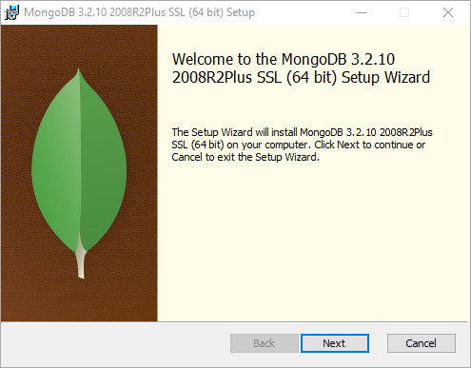

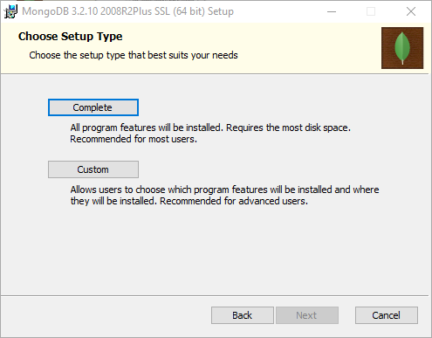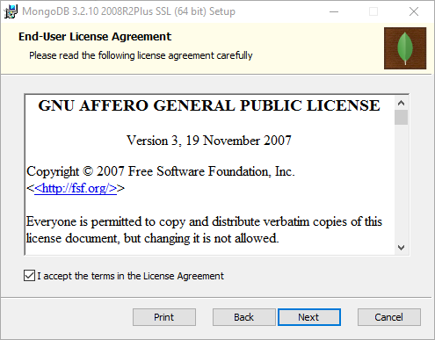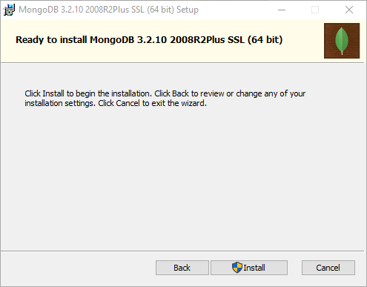

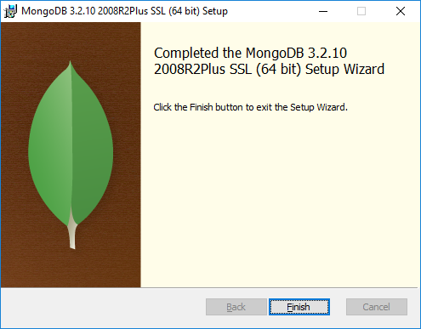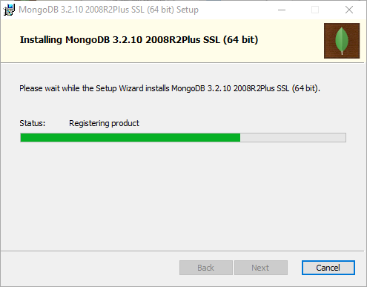

## Configuration

Go to MongoDB installation and find bin folder (if you have installed MongoDB in **C:\Program Files\MongoDB** then you should go in **C:\Program Files\MongoDB\Server\3.0\bin** folder). Here is how to set environment variable in **Windows**.

Inside the bin folder you can see a bunch of executable files (.exe). Among them mongo.exe is the client shell and mongod.exe is the server. Before running **mongod** and **mongo** from Command Prompt, you need to add **Path** [Environment Variables](https://en.wikipedia.org/wiki/Environment_variable) for MongoDB. Follow the following steps to set up the PATH environment variable:

1. Right click on **Computer**
2. Click on **Properties**
3. Click on **Advanced System Settings** which opens up a pop up box as below
4. Click on **Environment variables** and do as shown:

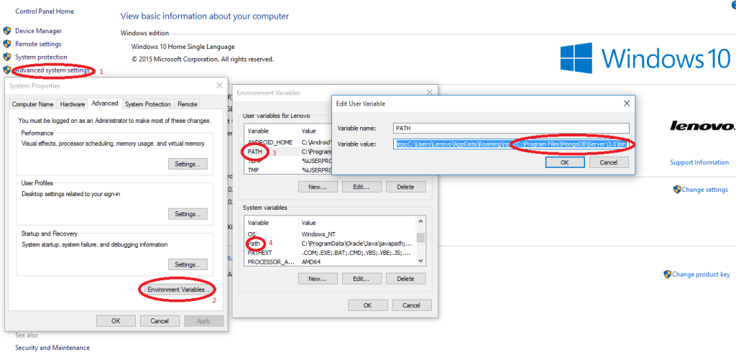

Now you need to create default directory (e.g.**C:\data\db**) for MongoDB. Once default directory for MongoDB is created, you need to open Command Prompt and type **mongod** which opens MongoDB server displaying **logs** and if you read the log messages, you come to know that the server is listening MongoDB clients at **port** **27017**. To keep the directory in other drives with different name than **C:\data\db**, you need to give the following **command** instead of only **mongod** in command prompt.

**mongod --dbpath D:\example\path**

Next you need to open **another** Command Prompt and put the command "**mongo"** which starts the **mongo shell** and connects with the**mongod server** via localhost at port 27017.

Now the MongoDB is installed successfully. You can run specific **commands** (create database/collections, insert entities and so on).

The example below is connecting (if not created – creates it) to a database named “test”. After that inserts entities into “**cities**” collection. Every inserted entity has **key** named “**name**” and some **value** against it.

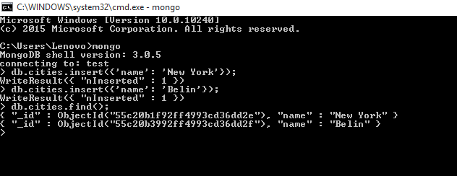

If you are on **Linux** you can do the same but you can look at this [thread](http://askubuntu.com/questions/500775/permanent-path-variable) to see how to set environment variables.

# MongoDB GUI (Optional)

The choice of MongoDB GUI is optional because it does not provide much more functionality (intellisense maybe), but some "**visual**" clarity. It runs the same [commands](https://docs.mongodb.com/v3.2/reference/command/) as the console client but the view is more "friendly".

## Robo 3T

Robo 3T is intuitive **cross-platform** GUI tool that excels in **displaying** data in **fast** mannered way. It has **free** and commercial license.

**Pros**:

* Easy to interact with.
* Fast.
* Cross-platform.
* It has free version.

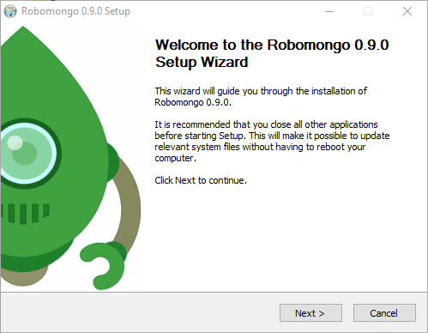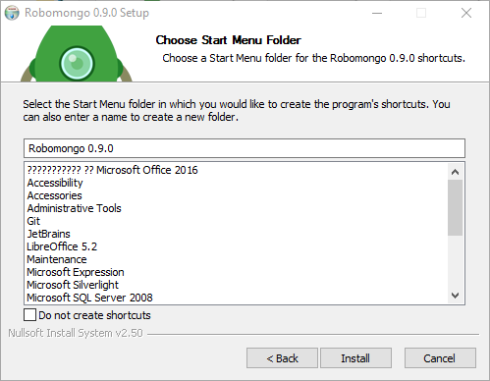You can **download** it from [here](https://robomongo.org/download).

After the download is completed you should **run** the **installer**.

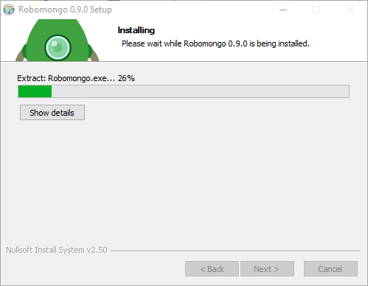

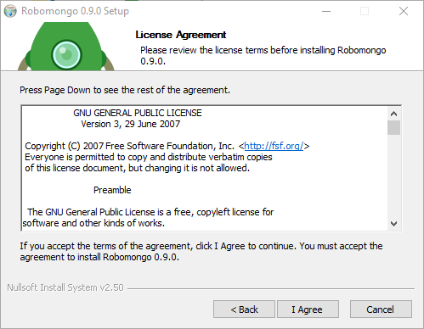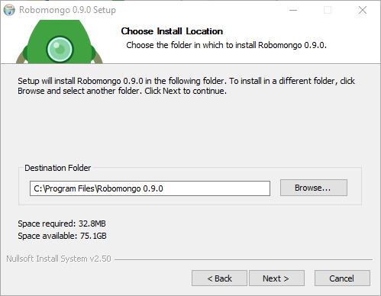

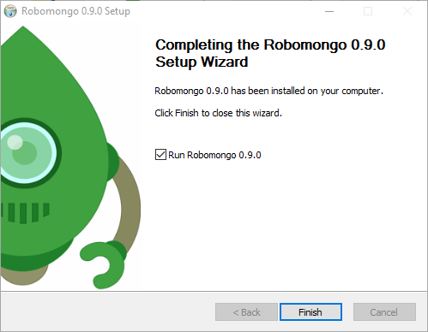

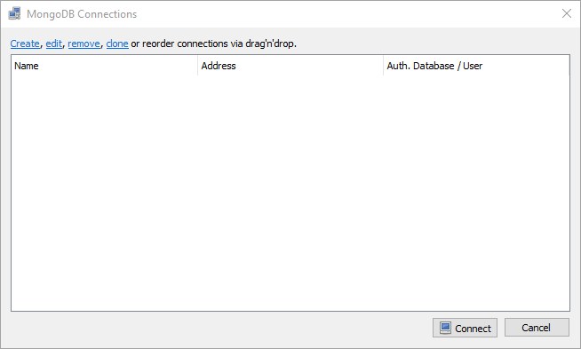After the install is completed have to **setup** a **connection.** It is **easy** since you have to do two things: **name** your **connection** – nothing specific for this one, and give a **port** for that connection – this means that the specific GUI has to connect with the server made by MongoDB therefore we should give the **port** that **MongoDB** is **using**. Default port is: **27017**. This also means that in order to use the program you must **open** that **connection** (that “mongod” **command**).

**Right** click on the white screen, the following options should appear:

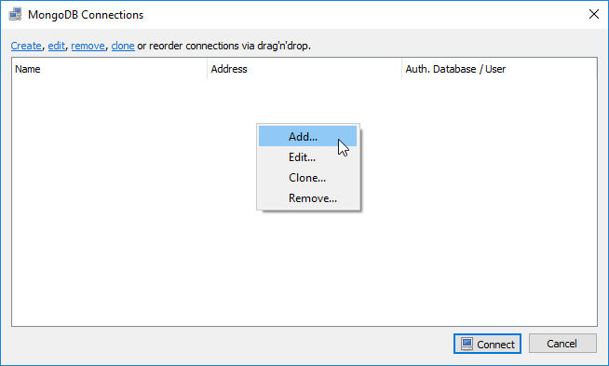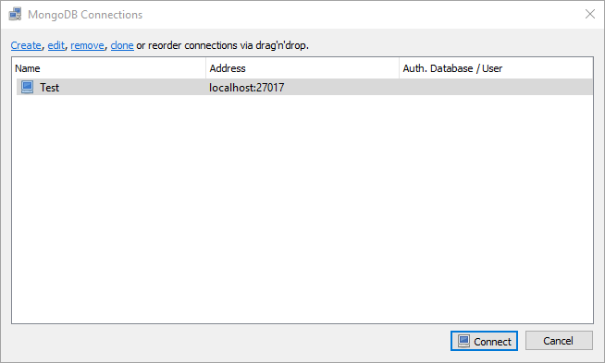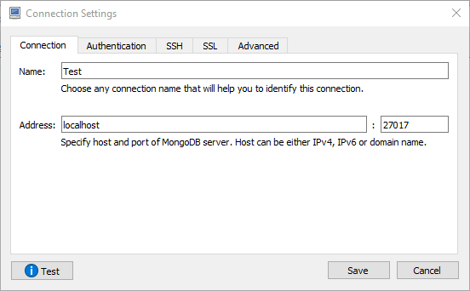

If you don't have your MongoDB connection open (the "**mongod**" thing) you should get this error:

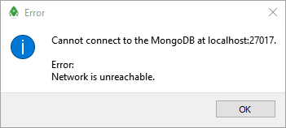

This means that you just simply need to open the **Command Prompt** and start database connection. It is the same if you are using the **console**: you can't watch over something that is not existing, right? Then create it.

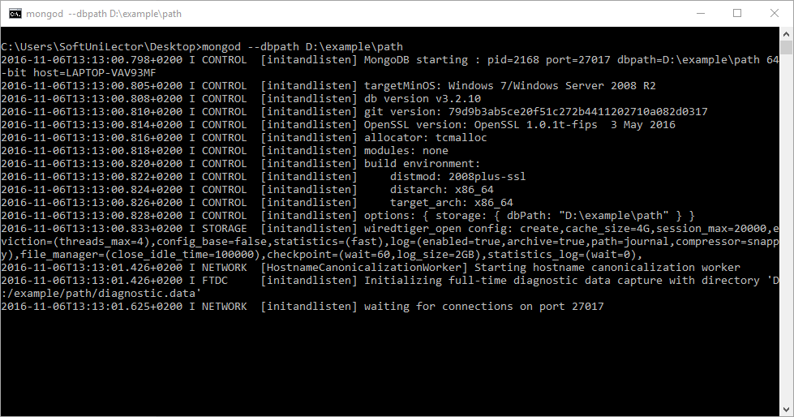

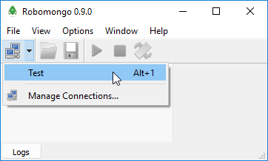Then try **again**.

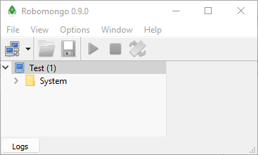And voila you can now use the GUI to manipulate current connection (create database/collections and so on).

You can choose **any** of those **two**, or even **another** GUI (e.g. [MongoBooster](http://mongobooster.com/), [RockMongo](http://rockmongo.com/), yes there are **more**) or **none**.